**MINISTRY OF EDUCATION AND SCIENCE OF UKRAINE**

**KHARKOV NATIONAL UNIVERSITY OF**

**RADIOELECTRONICS**

Education Center in English

Student of Specialty Computer Engineering

**Subject**: **Internet Technology**

Laboratory Work Report No: 3

|  |  |
| --- | --- |
| **Student**: | **Course Chief:** |
| Ngwu Victor | Ganna Zavolodko |
| KIYKLI: 18-2 |  |

**2021**

Task 1 (gallery)

1.       Create all gallery images in the images subdirectory

2.       (The folder images of your resource contains images 1.jpg, 2.jpg, 3.jpg, 4.jpg, 5.jpg, 6.jpg, 7.jpg, 8.jpg, 9.jpg ...)

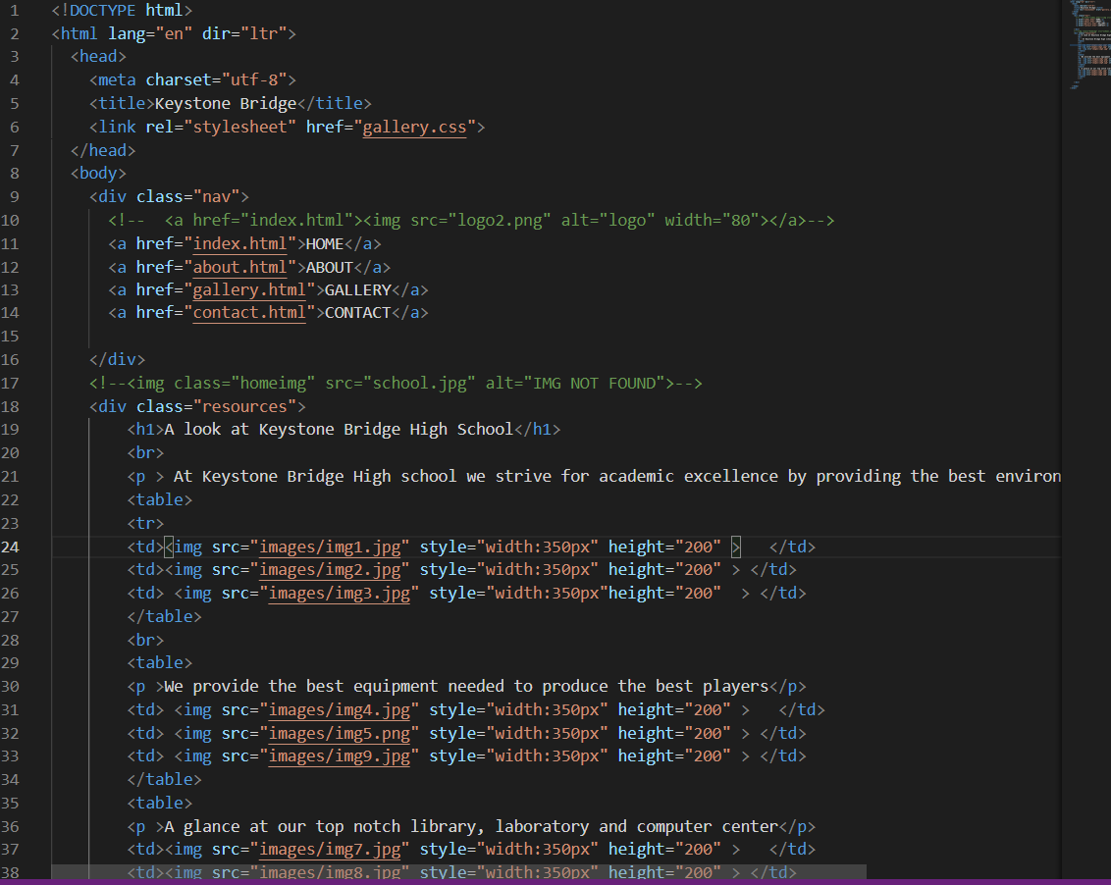

**Fig 1 is the code of gallery**

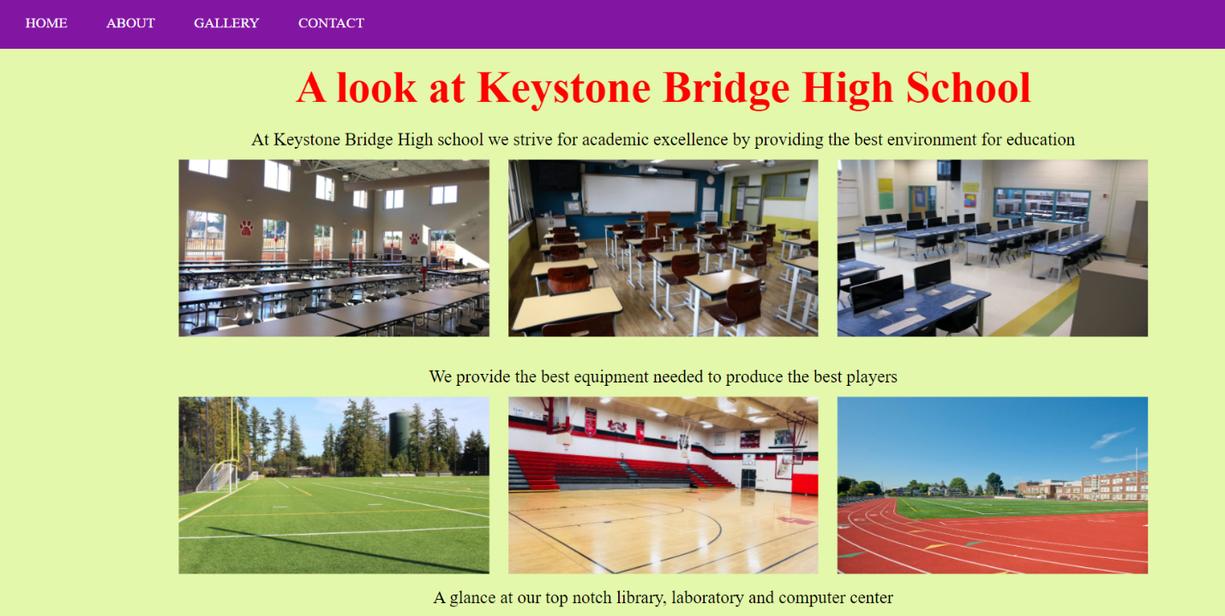

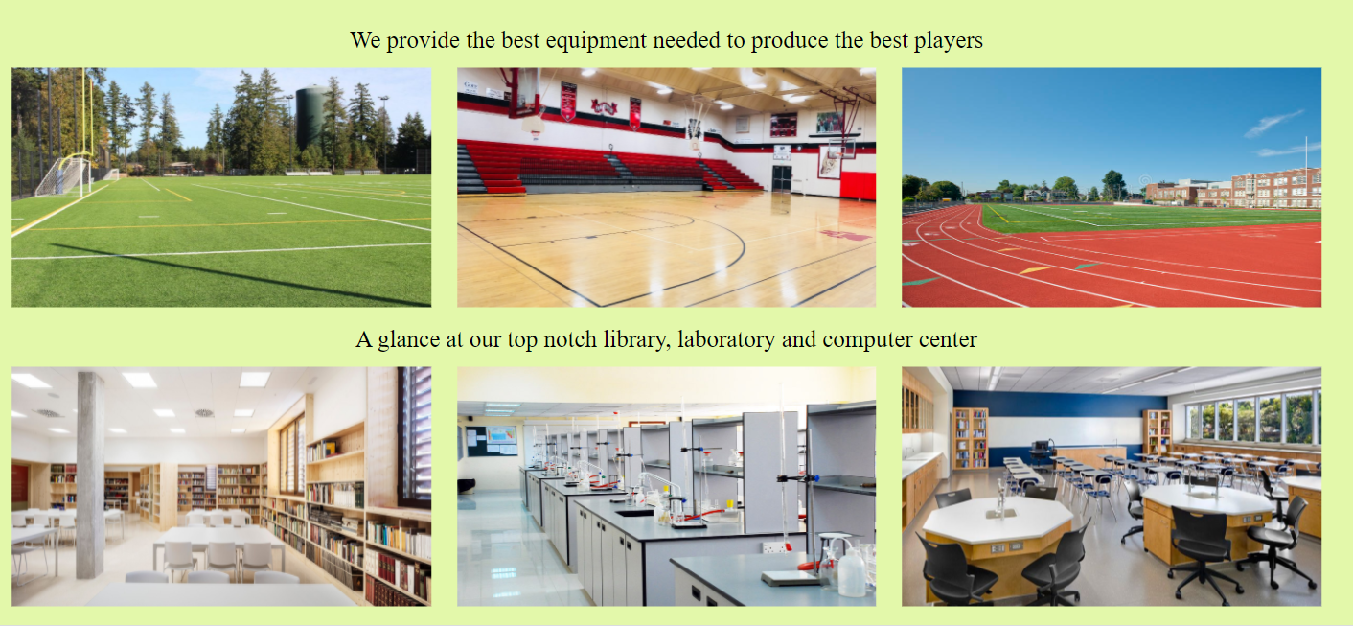

**Figure 2.1 and 2.2 are the results**

### Task 2 (creating a navigation bar with CSS)

1.       Create a navigation bar

2.       use overriding of CSS properties with minimal use of classes and identifiers

3.       the menu can be multi-level

4.       create missing website pages according to the brief



**Fig 3 is the result of the code for nav bar**

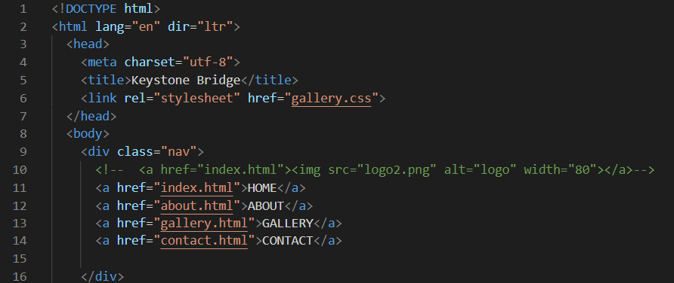

**Fig 4 is the code of navigation bar**

### Task 3 (Testing)

1.       Site testing

-       Check links.

·        checking the site for internal and external links for broken and missing pages

·        the presence of page 404.

2.       Usability testing (analyze site design for compliance with various criteria).

-       checking the conformity of the logo to corporate colours, colour lines;

-       principles of site usability.

·        The principle of "Visual Hierarchy".

·        The principle of the "Golden Section".

·        The principle of "Balance".

·        The principle of "Contrast".

3.       Navigation testing.

-       the number of road map to a a particular place on the site;

-       site search (keywords in meta tags); •

-       check the navigation of the "up" button

4.       Cross-browser testing.

-       selection of browsers for testing;

-       testing the site in different browsers

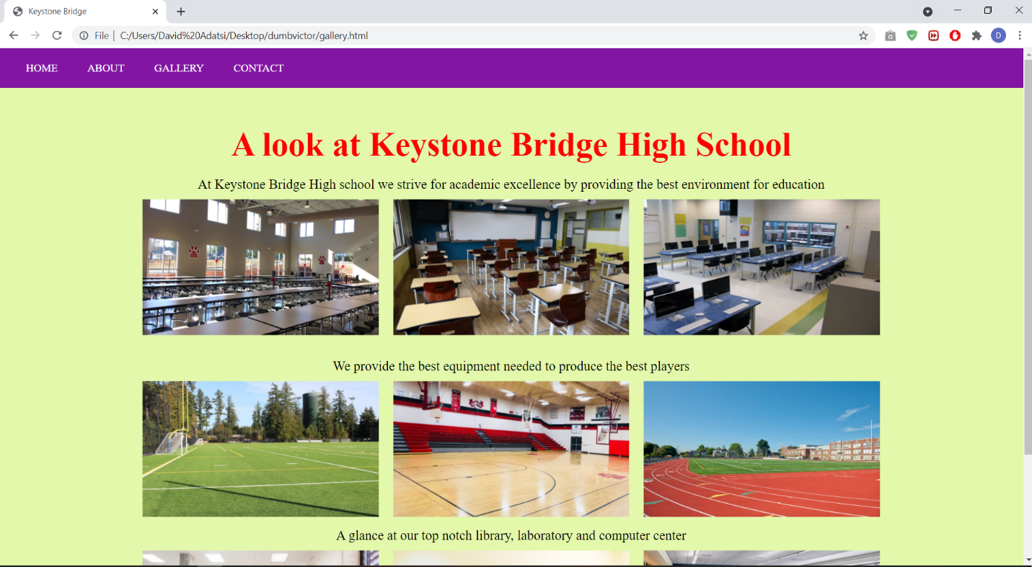

**Fig 5 is the testing of the site on chrome browser**

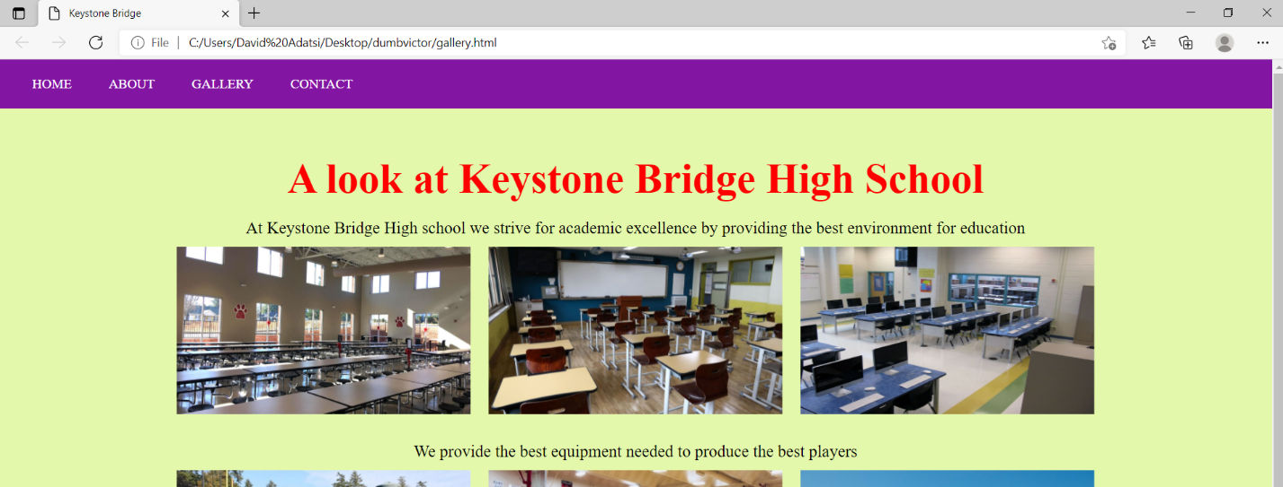

**Fig 6 is the testing on Microsoft edge**

**Conclusion**

Using Microsoft visual studio code, we were able to perform a set of tasks for the lab which was to create HTML script with a navigation bar and gallery using CSS. As you can see in figures 1-6 above, the task was successfully performed. As a result, a greater understanding on html and CSS has been gained. A link to the task is provided below:

https://github.com/NgwuVictor/Internet-Technology/upload/it-task-3